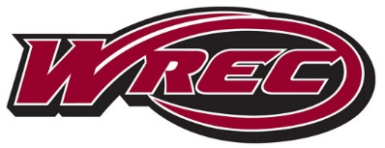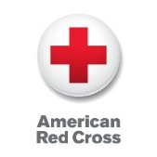**American Red Cross**

**CPR / AED and First Aid**

Description: Participants will learn basic life-saving skills to obtain their certification in First Aid and/or CPR/AED for adults, children, and infants.

Price: CPR/AED - $40, First Aid - $25

Certifications: Valid for 2 years from date of course completion

Conditions of Passing: Participants must pass a multiple-choice exam with a score of 80% or better to become certified.

**Fall 2019 Class Schedule**

|  |  |  |
| --- | --- | --- |
| **Day** | **First Aid** | **CPR/AED** |
| Tuesday 8/20 | 10a-12p | 12:30p-4:30p |
| Saturday 9/7 | 10a-12p | 12:30p-4:30p |
| Saturday 9/14 | 10a-12p | 12:30p-4:30p |
| Sunday 9/15 | 10a-12p | 12:30p-4:30p |
| Sunday 9/22 | 10a-12p | 12:30p-4:30p |
| Sunday 10/6 | No Class | 12:30p-4:30p |
| Saturday 10/12 | 10a-12p | 12:30p-4:30p |
| Saturday 10/19 | 10a-12p | 12:30p-4:30p |
| Sunday 10/27 | 10a-12p | 12:30p-4:30p |
| Sunday 11/3 | 10a-12p | 12:30p-4:30p |
| Sunday 11/17 | 10a-12p | 12:30p-4-30p |
| Saturday 12/7 | No Class | 12:30p-4:30p |
| Sunday 12/8 | 10a-12p | 12:30p-4:30p |