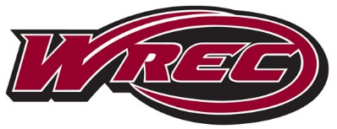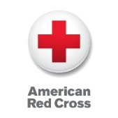**American Red Cross**

**CPR / AED and First Aid**

Description: Participants will learn basic life-saving skills to obtain their certification in First Aid and/or CPR/AED for adults, children, and infants.

Price: CPR/AED - $40, First Aid - $25

Certifications: Valid for 2 years from date of course completion

Conditions of Passing: Participants must pass a multiple-choice exam with a score of 80% or better to become certified.

**Spring 2020 Class Schedule**

|  |  |  |
| --- | --- | --- |
| **Day** | **First Aid** | **CPR/AED** |
| Saturday 2/8 | 10a-12p | 12:30p-4:30p |
| Sunday 2/9 | 10a-12p | 12:30p-4:30p |
| Sunday 2/16 | 10a-12p | 12:30p-4:30p |
| Saturday 3/7 | 10a-12p | 12:30p-4:30p |
| Sunday 3/8 | 10a-12p | 12:30p-4:30p |
| Saturday 4/4 | 10a-12p | 12:30p-4:30p |
| Sunday 4/5 | 10a-12p | 12:30p-4:30p |
| Saturday 4/18 | 10a-12p | 12:30p-4:30p |
| Sunday 4/26 | 10a-12p | 12:30p-4:30p |
| Saturday 5/2 | 10a-12p | 12:30p-4:30p |